**Admin rights Request**

Please go to <http://itsupport.verizon.com/tools/registration.aspx>

Click on **desktop registration executable**

A popup will appear

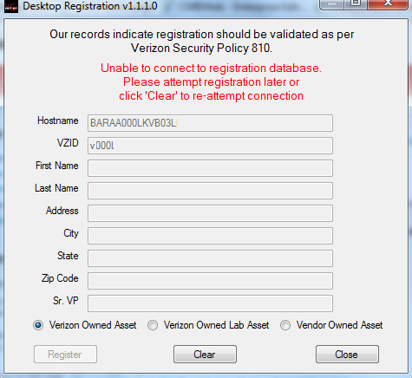

Check if your vzid is on **VZID field  if not click on CLEAR button  complete it and click on REGISTER button**

**Now go to Start-All programs-PC information and when the menu option appear click on left up corner on DESKTOP REGISTRATION**

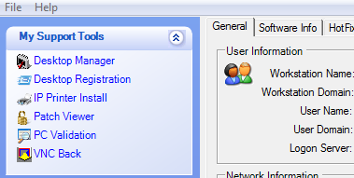

**In few seconds will appear a yellow popup**

**Complete the VZID field with your vzid and click on Register button**

**Once completed all the steps go to** [**http://itsupport.verizon.com/SSO/Support/FS/AdminRightsTool_New.aspx**](http://itsupport.verizon.com/SSO/Support/FS/AdminRightsTool_New.aspx)

**And go to end of Admin Rights Agreement document and click on I agree button.**

**LAR privileges will expire at the end of 12 months; if needed, user will re-submit request for LAR**

**Later of agreement will appear a FORM for complete**

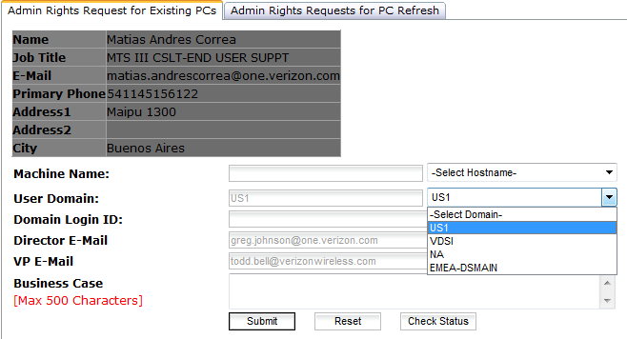

**Click on SELECT HOSTNAME drop list check if appear your computer name and select it.**

**User Domain :Select EMEA –DSMAIN**

**Business Case: your Business justification.**

**Once complete it all the steps click on Submit button**

**When the Admin rights are approved you go to receive a mail with the instructions for update Admin rights through Marimba.**